**Part I: Environment setup**

Setting up Spark/Python environment on local machine using virtual machine.

**Step 1: Download and setup VirtualBox with Ubuntu**

1. Download VirtualBox at <https://www.virtualbox.org/wiki/Downloads>
2. Install VirtualBox and you will see the following.



1. Go to <https://www.ubuntu.com/download/desktop> to download Ubuntu. The file is about 1.5GB so the download may take some time. Once the download is completed, you should see the Ubuntu iso file in your Downloads folder.
2. Open VirtualBox, create a new Virtual Machine as follows:
   1. Click on New
   2. Fill out the “Create Virtual Machine” pop-up window step by step.
      1. For “Name and operating system”, name your machine, make “Type” be Linux, and choose your version based on your system



* + 1. For “Memory size”, choose reasonable amount of memory based on what you have.



* + 1. For “Hard disk”, choose “Create a virtual hard disk now”



* + 1. For “Hard disk file type”, choose “VDI”



* + 1. For “Storage on physical hard disk”, choose “Fixed size”



* + 1. For “File location and size”, choose a reasonable size based on your system (remember the operating system alone is more than GB, 10GB minimum)



* + 1. Click “Create”



* 1. Once the creation is done, through your VirtualBox manager you should see something similar to the following, with the virtual machine your created displayed:



1. Right click on your virtual machine and choose “Settings”. In the left panel, choose “System” and then choose the “Processor” tab, choose the number of processors (remain in the green zone). Also click on the “Screen” tab and choose proper “Video Memory”. Click on “OK”.





1. Double click on your virtual machine, and install Ubuntu on your virtual machine follow the step by-step guide.

Then you need to follow the steps to install Ubuntu on your virtual machine:

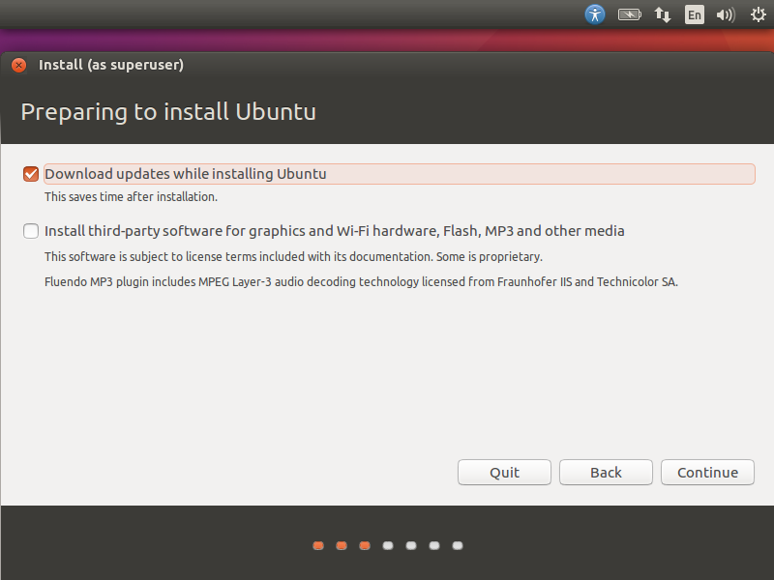

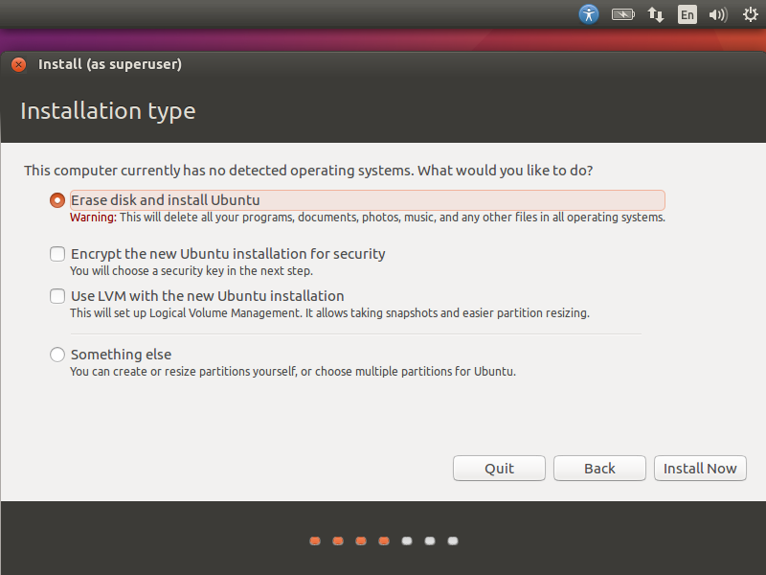

1. Once the installation is done, you restart your virtual machine and you should see something similar to the following, that is the desktop of your virtual machine:

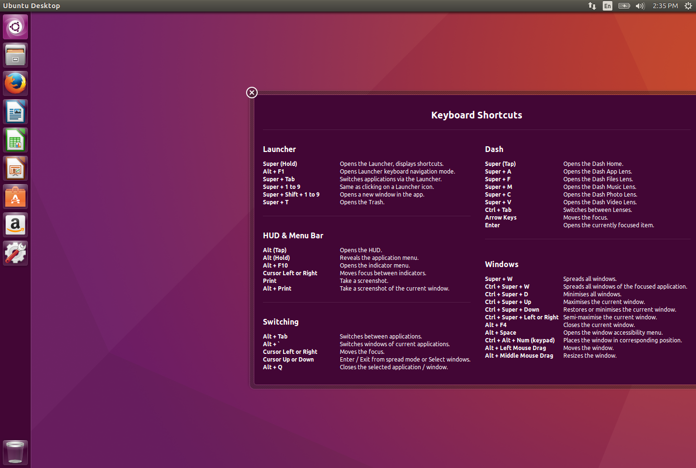

**Step 2. Set up the Spark + Python environment on your virtual machine**

1. Inside your virtual machine, open the terminal. Using command line to make sure you have python3.



1. Install jupyter notebook system.



(this installs pip3, we will use pip3 to install other python packages)



(this installs jupyter. Jupyter is a web application that allows you to create and share documents that contain live code, equations, visualizations and comments. It supports many programming languages including python).



(this installs java because we need scala)



(this installs scala since we need to install Spark)



(this installs py4j, Py4J enables Python programs running in a Python interpreter to dynamically access Java objects in a Java Virtual Machine).

Inside your virtual machine, use the browser to go to Spark website and download Spark 2.1.1.

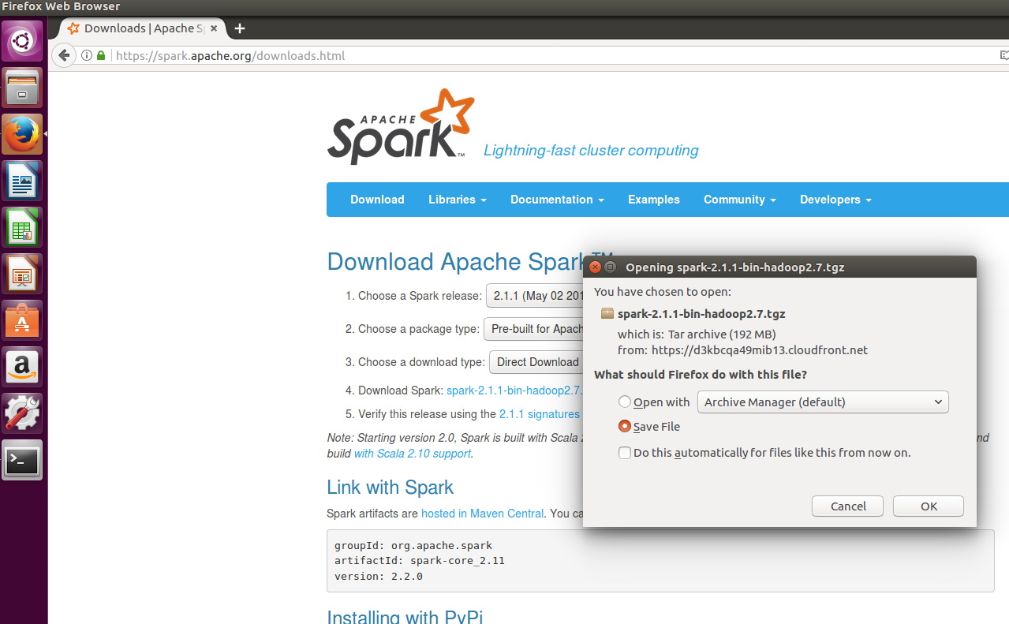

Remember to move the downloaded file to home directory.

Then go back to your terminal and do following:



(this unzips and installs the Spark and Hadoop)

After the unzip finishes, do following to set up the path correctly:



Now, we need to do something to avoid permission errorcd s:



In python folder, test your jupyter notebook.



And you should see jupyter notebook shows up in your browser.

1. Some extra steps that allow you to import pyspark from any directory.

